

RSC Merchandising Dashboard

Contents

**1. Report Objective** 1

**2. Version / Change Log** 1

**3. Data sources** 2

**4. KPI/Measures** 2

**5. Tools** 2

**6. Data Flow** 2

**7. PBI Measures** 2

**8. Annex** 3

# **1. Report Objective**

|  |  |
| --- | --- |
| **To** | Have a timely monitoring of Key Metrics for Merchandising Team |
| **In a way that** | Can be viewed thru a dashboard that is readily available and easy-to-navigate. |
| **So that** | Merchandising can make faster data-driven decisions and actions that will lead to an increased revenue. |

# **2. Version / Change Log**

|  |  |  |
| --- | --- | --- |
| **Version** | **Updated by:** | **Change** |
| 1.0 | Raphael Francis R. Flores | Created Document |
|  |  |  |

# **3. Data sources**

|  |  |  |  |
| --- | --- | --- | --- |
| URL | Database | Schema | Table / View Table |
| robinsons-ma-prod-redshift.crrofu8ekzrf.ap-southeast-1.redshift.amazonaws.com:5945 | ma_dwh | public | dim_store  dim_product  dim_vendor  dim_date  mly_agg_str_prod |
|  |  |  |  |

Power BI dataset:

The dataset is configured in Import mode.

# **4. KPI/Measures**

The list of measures and how they are calculated can be found on below link.

[https://jgsoffice.sharepoint.com/sites/AnalyticsTeam/Shared%20Documents/ITD%20-%20ADVANCED%20ANALYTICS/Projects/BU/TGP/DC%20Operational%20Dashboard/KPI%20architecture%20for%20Dashboard%20Warehouse.xlsx](https://jgsoffice.sharepoint.com/sites/AnalyticsTeam/Shared%20Documents/ITD%20-%20ADVANCED%20ANALYTICS/Projects/BU/RSC/RSC/RSC%20Merchandising%20Dashboard/Merchandising%20Dashboard%20Phase%201%20V2.xlsx)

# **5. Tools**

|  |  |  |
| --- | --- | --- |
| **Tool** | **Details** | **Refresh Schedule** |
| Power BI | Used for Visualization | N/A |
| Power Automate | The tool used to trigger the PBI refresh | Monday 6:30am Mon – Sat after RSC ETL |

# **6. Data Flow**





# **7. Power BI Data Model**

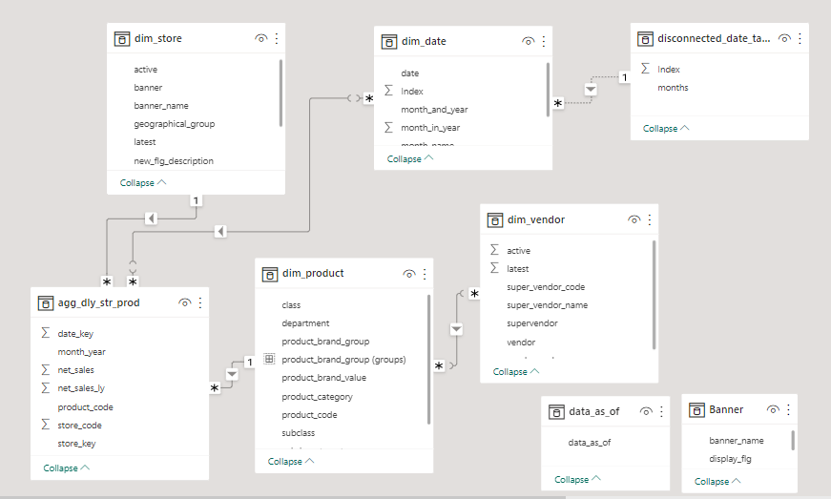

|  |  |
| --- | --- |
| **Table** | **Custom SQL import script** |
| dim_product | n/a |
| dim_store | n/a |
| dim_vendor | n/a |
| dim_date | n/a |
| data_as_of | Select max(date_key)::varchar as "data_as_of"  from public.agg_dly_str_prod |
| agg_mly_str_prod | with dim_product_cte as (  select product_code  from public.dim_product dp  where merchandise_flg = 1 and latest = 1 and active = 1  ),  dim_date_cte as (  select to_date(dd.date_key, 'YYYYMMDD')::date as "date_key"  from public.dim_date dd  where 1=1  and dd.date_fld >= '20210101' and dd.date_fld <= '20230418')  select  amsp.date_key  ,date_trunc('month', to_date(amsp.date_key,'YYYYMMDD'))::date as "month_year"  ,store_key  ,store_code  ,product_code  ,sum(sale_net_val) as "net_sales"  ,sum(sale_net_val_ly) as "net_sales_ly"  from public.agg_mly_str_prod amsp  inner join dim_date_cte dd on date_trunc('month', to_date(amsp.date_key,'YYYYMMDD'))::date = dd.date_key  inner join dim_product_cte using (product_code)  group by 1,2,3,4,5 |

# **8. Power BI Measures**

[RSC Merchandising Dashboard Measures](https://jgsoffice.sharepoint.com/sites/AnalyticsTeam/Shared%20Documents/ITD%20-%20ADVANCED%20ANALYTICS/Projects/BU/RSC/RSC/RSC%20Merchandising%20Dashboard/RSC%20Merchandising%20Dashboard%20(Measures).xlsx)

# **9. Annex**

[Project Planning Document](https://jgsoffice.sharepoint.com/sites/AnalyticsTeam/Shared%20Documents/ITD%20-%20ADVANCED%20ANALYTICS/Projects/BU/RSC/RSC/RSC%20Merchandising%20Dashboard/Project%20Planning%20Document%20-%20RSC%20Merchandising%20Dashboard%20-%2008222022.docx)